Ben Peters A Level Photography 2nd final piece evaluation
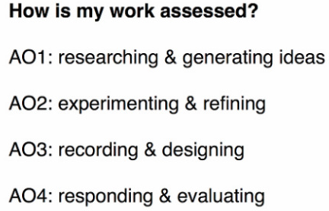

AO1:
The first research I did for this H/W was look into Conceptual Photography. I had to pick a photographer to research. I had a choice of Ed Rusha, John Baldessari, Victor Burgin, Keith Arnatt, Cindy Sherman, Sophie Call and Stephen Gill. I chose John Baldessari because one photo caught my eye. This photo caught my eye. The thing that caught my eye was the sky. This gave me the idea of taking silhouettes using trees and branches contrasting with the sky. After I first took a set of these where I had silhouettes with trees, I realised another thing I could do to take inspiration from Baldessari. His series called ‘Wrong’, this was where he deliberately took photos with a bad composition. One last thing I looked at with Baldessari was his ‘dots over peoples faces’ set. I really liked this idea of putting dots over faces because of how simple the idea is. It is simple because it was very simply putting a coloured sticker over a face. I decided that this series of photos will be the idea that I follow. Towards the end I did some quick research on an artist called Tacita Dean, she took pictures of tree and painted around the main tree in the foreground. This created an impression of mist. Dean will turn out to be the main motive of my 2nd final piece.

AO2:
My first experiment was taking silhouette photos. This idea came from the linked photo in AO1. These photos were very simply trees and branches that had been blacked out [silhouette] by the sun in the background. Initially these photos were good by I found out another way I could link these to Baldessari’s work. Baldessari took photos with a deliberately band composition which he called Wrong. So therefore I could retake these photos without a proper composition. However I decided to enlarge and rotate the original images in Photoshop. In the end I liked these photos however I felt that I would of been better following a different aspect of Baldessari’s work. I did this in my next photoshoot. On the 28th of December my Uncle had a christmas party round his house and I was one of the photographers. I took loads of group photos and individual photos at the party. At the end my uncle said to me “I would prefer if photos of me aren’t uploaded to the internet”. This is because my uncle is an executive of a company. After he said that to me, I remember back to the “put dots over peoples faces” from the video. I said to myself “Uncle your the perfect person for this kind of photo”. So when I got home I put the best images into Photoshop and I applied B&W to all of them, then I added dots over everyones faces. I believe that these images worked very well. The next experiment I did was take close up photos of branches on trees. Next I made these images similar to the work of Baldessari. I went in Photoshop and I added a different colour to the branches of the trees. I believe that this idea worked better than putting dots on peoples face because adding dots gives a sense of multiple layers to the image. However changing the colour of the branch, still makes it feel like a photographic image. I was going to use the best of these images for my final piece where I would have a map of Sutcliffe park in the middle then I would have the pictures going around the map. I would have string showing where I was standing when I took the specific photo. However me and Mr Nicholls thought that this wouldn’t be a good idea because we would of had a low resolution and dark image in the middle with high resolutions images with bright colours going around it. However sir did say that if the images weren’t edited than this idea would work for a final piece. So I did one more experiment on photoshop with the same images. Rather than changing the colour of the branches, I painted the background completely white. This came from what Tacita Dean did. She took images of trees then blew them up to the size of a wall and then painted around the tree. So I decided to do a digital version of this using Photoshop. This involved using ‘Colour Range’ and ‘Brush Tool’. After this I mounted the images using the display strategy of Multiples. I’ve decided not to leave white gaps because if I have all the images together, it can form a good abstract contrast of colour, especially if the branches line-up with each other.

AO3:
To make this final piece I used a good amount of photographic equipment. For the first photo shoot with the silhouettes. I used a diffractor filter. Diffractor filters cause an explosion of colour around a light source. I decided to use this because I believe that the explosion of colour will look very good in a photo which is of a silhouette. I had to ‘free lens’ the diffractor filter because filter was a Cokin size A filter and my camera is 58mm. The filter was bigger and I didn’t have any adapters. However because it was bigger than the lens, I could ‘free lens’ it with ease. All of the photoshoots involved the use of either a Canon 400D or a Canon 550D DSLR. For some of the photos of branches I had to use a 70-300mm Telephoto lens, this was so I could get all the way in on the branches in a sought of Macro detail. For the photos that were inspired by Baldessari, the dots on peoples faces, changing the colour of branches and changing the colour of the background all involved the use of Photoshop. This needed to use a wide range of features on Photoshop like ‘Colour Range’, ‘Quick Selection Tool’, ‘Magic Wand’ and ‘Brush Tool’. I also had to use the Adjustment ‘Black & White’. The quick selection tool and the magic wand was used for the changing the colour of the branches. However when I had to change the colour of the background I was advised by Mr Nicholls to use Colour range rather than Magic wand. Finally the B&W adjustment was used for the ‘dots on people faces’ shoot because I had to change the colour of the image to black and white to make the contrast with the colour dots better.

AO4:
I’m happy with my second final piece for a couple of reasons. The first reason why I like it is because the of the nice pattern it makes. Despite the fact that the most of the branches don’t line up with each other, putting them together has actually produced a very good spooky image and also a good contrast. A second reason that I liked it is because of my mounting of it. In my previous final piece I’d struggled with the actual mounting of the final piece, however I believe I have done well this time because the pictures line up, the cutting is straight and the spray mount hasn’t stained the images. I believe that this final piece it better than what I was intending to do. This is because the images I have used are of good quality. However the only problem me and Miss encountered when mounting was that somehow the images didn’t go straight down the board. However we trimmed to board down. So we compensated for the failure to stick in a straight line. Overall I prefer this final piece to the first one. The reason why is because I believe that the actual mounting of the final piece was executed better because the photos look more neater. Mainly because Miss helped me with the mounting. I believe this final piece shows a contrast in colour and pattern. The colour aspect is because the branches are black and the background is white. Also the colours are so bold that the difference is even better. The contrast in pattern is because in most of the images, the branches go in different directions. Finally I also believe there is a contrast in Focus because the photo in the top right has got the front branches in focus and the background ones as out of focus.

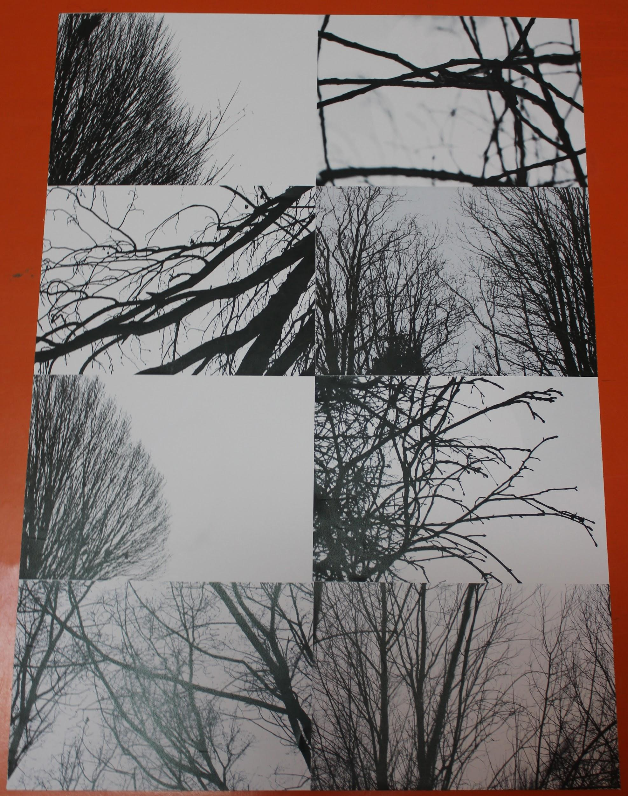
My 2nd final piece:

